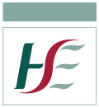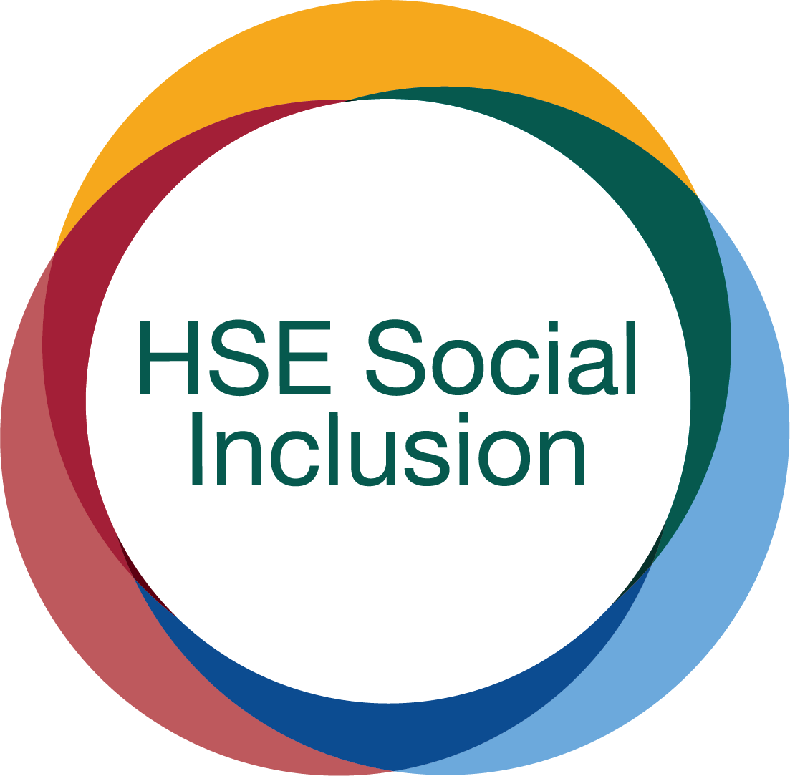

Responding to an opioid overdose during the COVID-19 pandemic

Information may be subject to change as we progress through the pandemic.
1. Look out for the signs of overdose – blue lips/nails, dizziness, confusion, choking, gurgling sounds, snoring, shortness in breaths, no breathing, cannot be woken
2. Call for help – get a staff member or call 999/112 providing the EirCode of the location and wait with the person until help arrives. At this point it is advisable to put on personal protective equipment (PPE). If available, people should wear gloves, an apron and eye protective goggles.
3. Check the persons breathing - look at their chest movements to see if they are breathing. Don’t put your face or ear near theirs
4. If the person is breathing
- Put them in the recovery position
- Administer naloxone
5. If the person is not breathing
- Provide 30 chest compressions at a time without rescue breaths. Remember that chest compressions can make a person cough or vomit so ensure you are protected during this time.
- Put the person in the recovery position
- Administer naloxone
6. Wash your hands and don’t let others into the area until cleaned
- After contact with the person wash your hands with soap and water for at least 20 seconds at the earliest opportunity. Alcohol hand gel is recommended if soap and water is not available.
- Avoid touching your mouth, eyes or nose, unless you have recently cleaned your hands after having contact with the individual.

