**A guide to registering on www.hseland.ie**

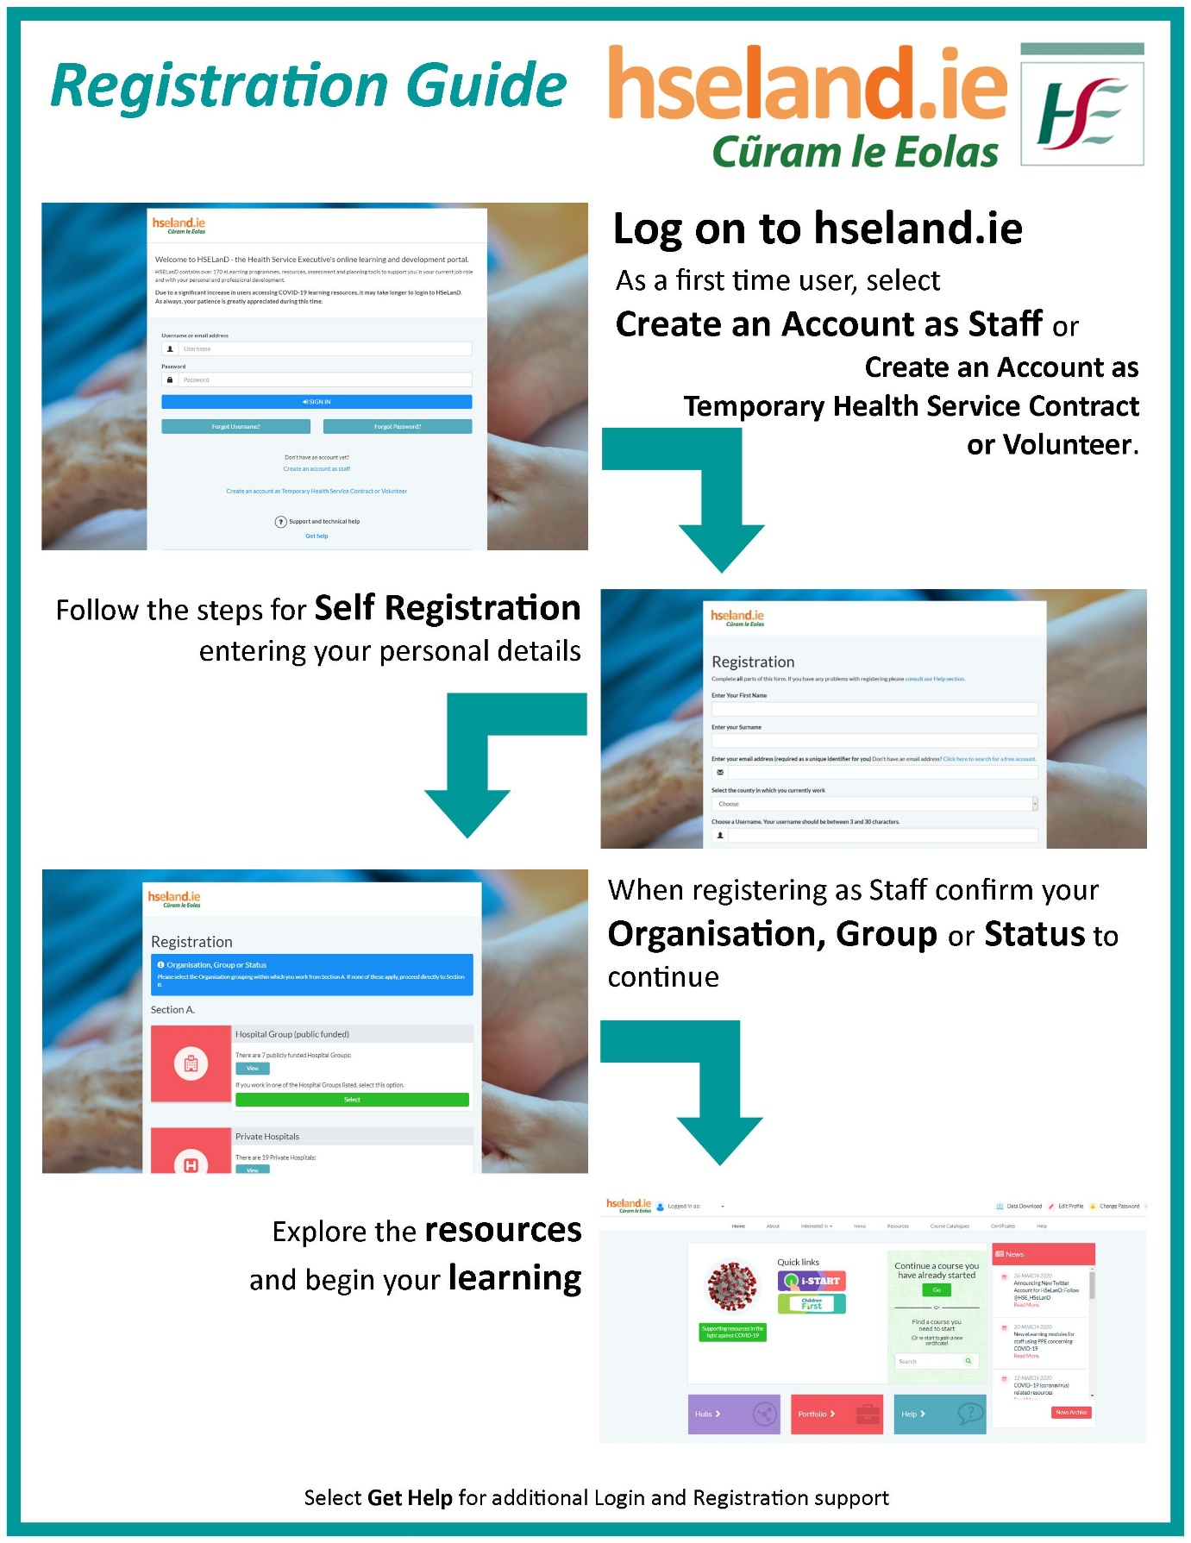

For funded agencies, users select this section in the registration form – ‘Other Funded Agencies’.

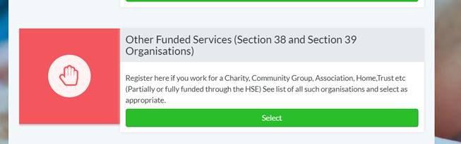

The registration option for Volunteers is available at the bottom of the log on page also. The learner just needs to select ‘Volunteer’ from the drop down when prompted.

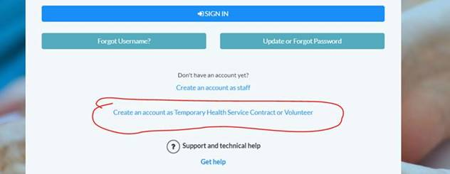

For further help please see the HSeLanD **Get help** section -  [https://www.hseland.ie/dash/Account/RegistrationHelp](https://scanner.topsec.com/?u=https%3A%2F%2Fwww.hseland.ie%2Fdash%2FAccount%2FRegistrationHelp&t=a891473f0dd4cafa64411718586577f2ad0b6a27&d=1824)